**Opening Menu**

Theopening menu will be the first thing presented to users when they open the game. The duck hunt logo will be displayed along with the the three different game modes available for the player. The player should be able to access the game mode of their choice by clicking on either Game A, B or C.

Additionally the user's top score during that specific session of play time will be displayed on the opening menu. This means if the user were to completely close the game and open it again the top score would reset back to 0.

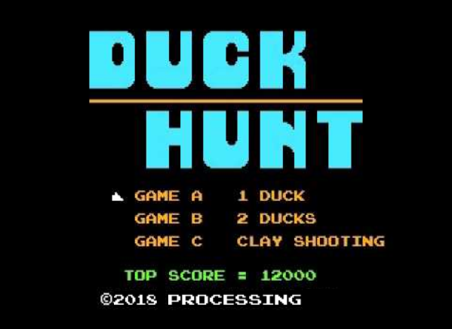

**Rules and Specifications of Game Mode A**

Game Mode A of Duck Hunt is the single duck mode. It begins with the animated loop of the hound sniffing around, and the first round being displayed on the middle of the screen. The round number is displayed on the bottom of the screen as well as a the number of bullets available, fully reset hit indicator and score (image 1.1).

Image 1.1

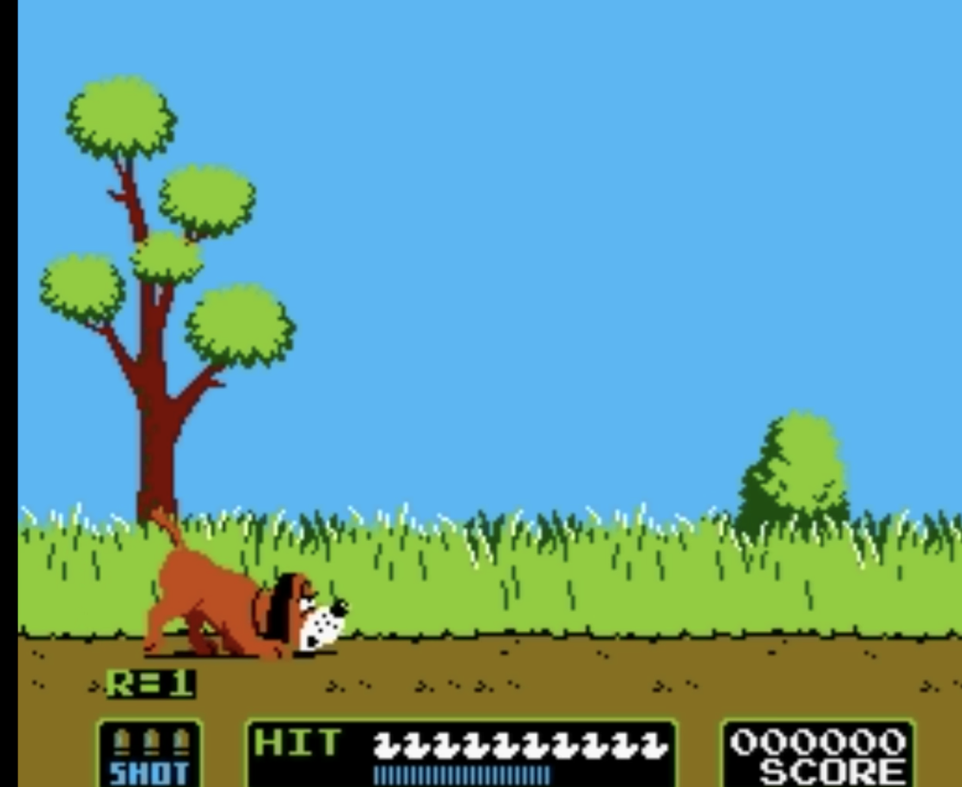

Mode A will have 25 rounds, giving the player the opportunity to hit 10 birds each round. Once the bird is released the player has 6 seconds or three bullets to shoot down the bird. The bird is released from a random location, and follows a random trajectory. If a bird reaches the top or the sides of the screen it will change direction. Birds are considered shot when the player successfully aligns the mouse cursor with the flying birds hit box and clicks. The flashing duck at the bottom of the screen is the hit indicator (image 1.2) and will turn red if a hit is scored. A miss occurs when all three shots are unsuccessfully used up, or when time has run out. A miss is shown on the hit indicator as a white duck or an empty space. After the user has either hit or missed the birds the shots are fully reset for the next bird.

Image 1.2



In the event that a bird has been shot down, it will fly head first to the bottom of the screen. At that point an animation of the dog will appear holding up the bird behind a bush (image 1.3). If the bird flies away and a miss is recorded, the dog will appear behind the bush laughing (image 1.4).

Image 1.3 Image 1.4

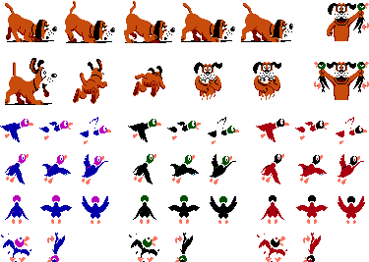 

The points received shows up on the screen wherever a hit is made (image 1.5) and is added to the total score shown at the bottom of the screen (image 1.6). The number of points the player receives for each kill is dependent on the round and the colour of the bird shot. A Perfect Bonus is awarded and displayed on the middle of the screen (image 1.7) when a round is ended without a miss. This number is also dependent on the round that the player completed.

|  |  |  |
| --- | --- | --- |
| Image 1.5 | Image 1.6 | Image 1.7 |

Table 1.8 illustrates the point system for Mode A

Table 1.8

|  |  |  |  |  |  |
| --- | --- | --- | --- | --- | --- |
| **Duck** | Rounds 1 - 5 | Rounds 6 - 10 | Rounds 11 - 15 | Rounds 16 - 20 | Rounds 21 - 25 |
| Black | 500 | 800 | 1000 | 1000 | 1000 |
| Blue | 1000 | 1500 | 2000 | 2000 | 2000 |
| Red | 1500 | 2400 | 3000 | 3000 | 3000 |
| Perfect Bonus | 10000 | 10000 | 15000 | 20000 | 30000 |

Each round ends after 10 ducks have flown out of the shrub. The Pass Line at the bottom of the screen below the hit indicator (image 1.9) shows the minimum number of ducks that must be hit in order to advance to the next round. If the hit indicator has reached the Pass Line by the end of a round, the player advances to the next round; otherwise, the game is over, a game over graphic is displayed on the middle of the screen (image 1.10), and the player is returned to the main menu.

Image 1.9



Image 1.10

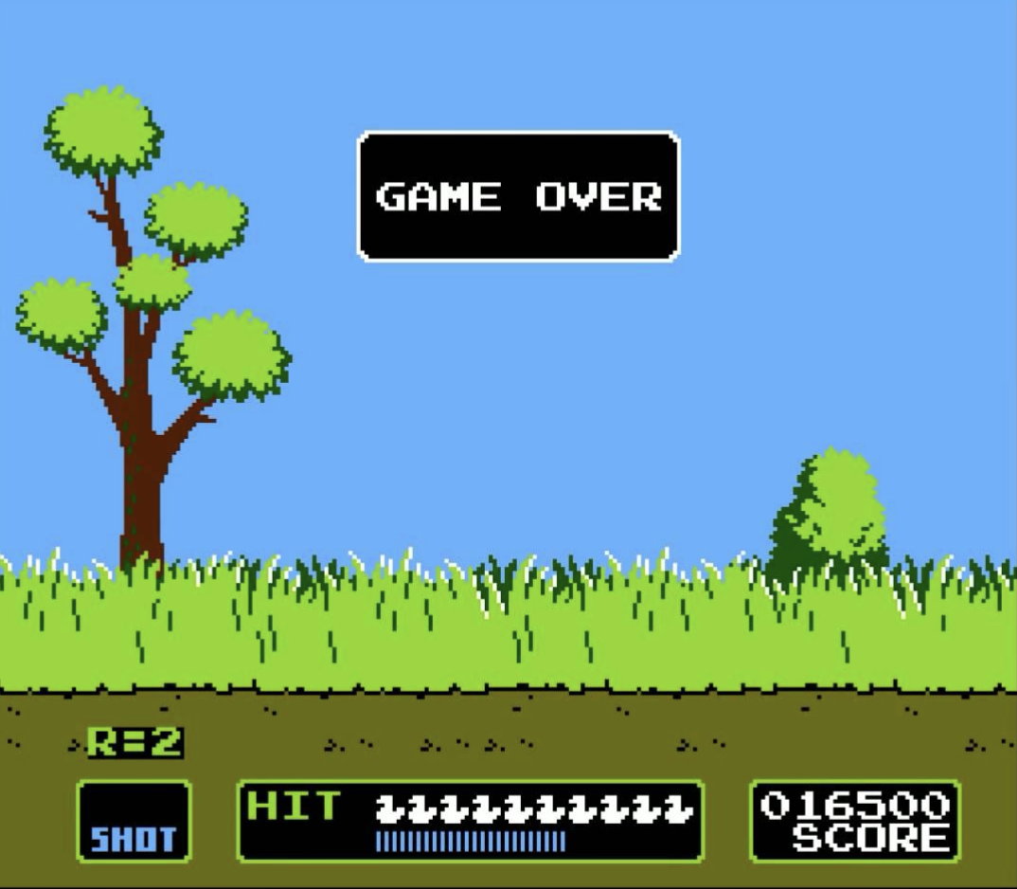

The ducks fly faster, and the number of ducks in the Pass Line increases as the user advances to later rounds. Table 1.11 illustrates the change in the requirements of the Pass Line as the game progresses.

Table 1.11

|  |  |  |  |  |  |
| --- | --- | --- | --- | --- | --- |
| Round Number | **1 - 5** | **6 - 10** | **11 - 15** | **16 - 20** | **21 - 25** |
| Minimum number of ducks hit in order to pass | 5 | 6 | 7 | 8 | 9 |

**Rules and Specifications of Game Mode B**

Mode B of Duck Hunt is the two duck mode. Mode B would will follow the same rules, have the same point system and difficulty progression (refer to tables 1.8 and 1.11) as Mode A, but will have 2 birds flying simultaneously on the screen (image 2.1). It is important to note that the birds in Mode B continue to act as individuals, and are shot down one bullet at a time. One bullet can not shoot down two birds.

Image 2.1

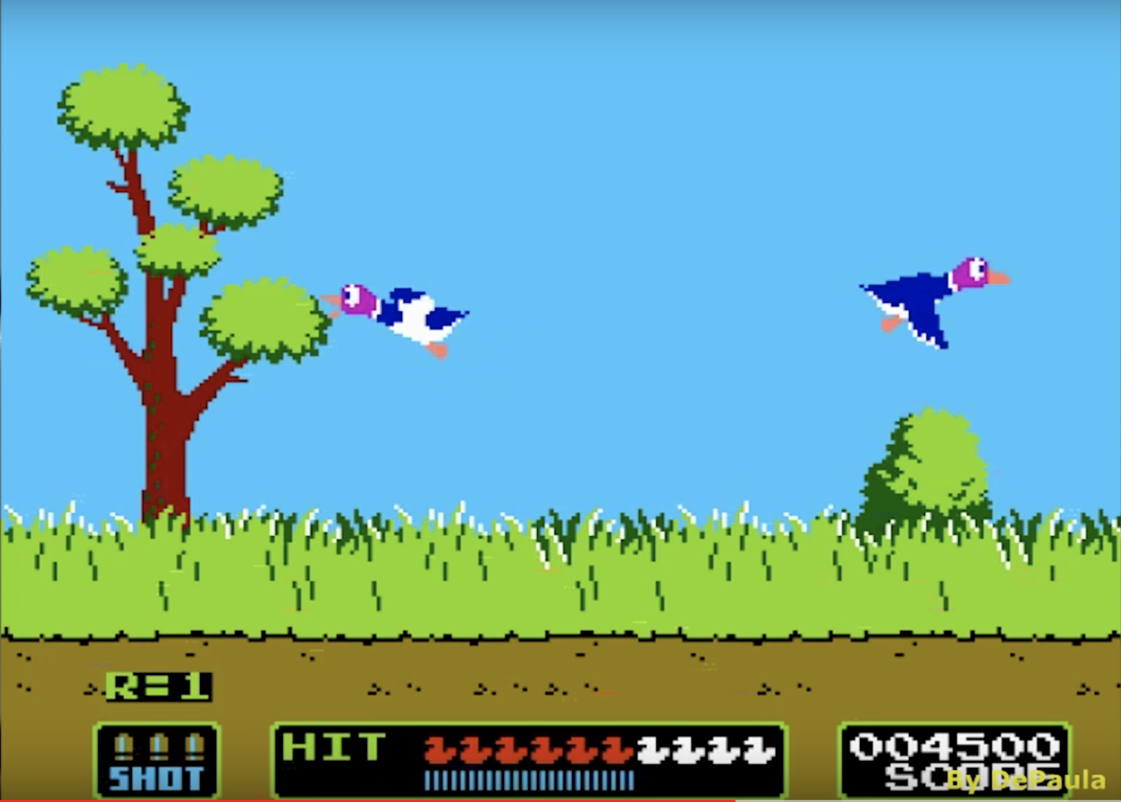

The display and graphics of Mode B will also remain the same as Mode A with the exception of the background and a new animation added of the dog coming up behind the bush when both birds are caught. In the event that both birds are shot after the maximum number of bullets is fired the hound will stand up behind the shrubs and showing two ducks (image 2.2). The animations for 1 or no birds being caught will be the same as in game Mode A (refer to images 1.3 and 1.4).

Image 2.2



**Rules and Specifications of Game Mode C**

Mode C of Duck Hunt is the clay disk shooting mode. There is no animated introduction in the beginning of this mode unlike A and B. The bottom of the screen has a similar display from the previous modes, including the round number, the number of bullets available, fully reset hit indicator and score (image 3.1).

Image 3.1

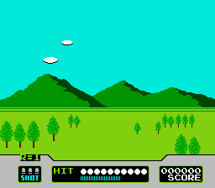

Mode C will have 25 rounds, giving the player the opportunity to hit 10 clay disks each round. 2 disks will be released simultaneously on the screen and the player will have 3 bullets to shoot them down. The disks are released from a random location, and will fly straight towards the top of the screen, shrinking in size to give the appearance of them flying further away from the player. Disks are considered shot when the player successfully aligns the mouse cursor with the disks hit box and clicks. The flashing circle at the bottom of the screen is the hit indicator (image 3.2) and will turn red if a hit is scored. A miss occurs when all 3 shots are unsuccessfully used up, or the disks have left the screen. A miss is shown on the hit indicator as a circle or an empty space. After the user has either hit or missed the disks the shots are fully reset for the new set of disks.

Image 3.2

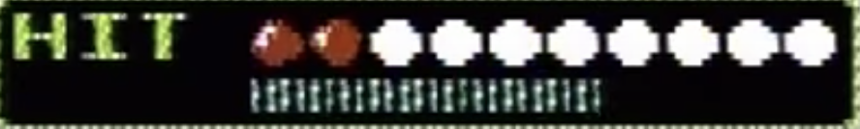

When a clay disk is shot down it will be indicated by a small explosion on the screen (image 3.4). In addition, the points received will show up on the screen wherever the hit is made (image 3.5) and is added to the total score shown at the bottom of the screen (refer to image 1.6)

|  |  |
| --- | --- |
| Image 3.4 | Image 3.5 |
|  |  |

Table 3.6 illustrates the point system for Mode C.

Table 3.6

|  |  |  |  |  |  |
| --- | --- | --- | --- | --- | --- |
| **Rounds** | 1 - 5 | 6 - 10 | 11 - 15 | 16 - 20 | 21 - 25 |
| Clay Disk | 1000 | 1500 | 2000 | 2000 | 2000 |

Each round ends after 10 clay disks have been released. The Pass Line at the bottom of the screen below the hit indicator (image 3.7) shows the minimum number of disks that must be hit in order to advance to the next round. If the hit indicator has reached the Pass Line by the end of a round, the player advances to the next round; otherwise, the game is over, a game over graphic is displayed on the middle of the screen (refer to image 1.10), and the player is returned to the main menu.

Image 3.7



The number of clay disks in the Pass Line increases as the user advances to later rounds. Table 3.8 illustrates the change in the requirements of the Pass Line as the game progresses.

Table 3.8

|  |  |  |  |  |  |
| --- | --- | --- | --- | --- | --- |
| Round Number | **1 - 5** | **6 - 10** | **11 - 15** | **16 - 20** | **21 - 25** |
| Minimum number of clay disks hit in order to pass | 6 | 7 | 8 | 9 | 10 |

**Graphics**

Background of Game Mode A

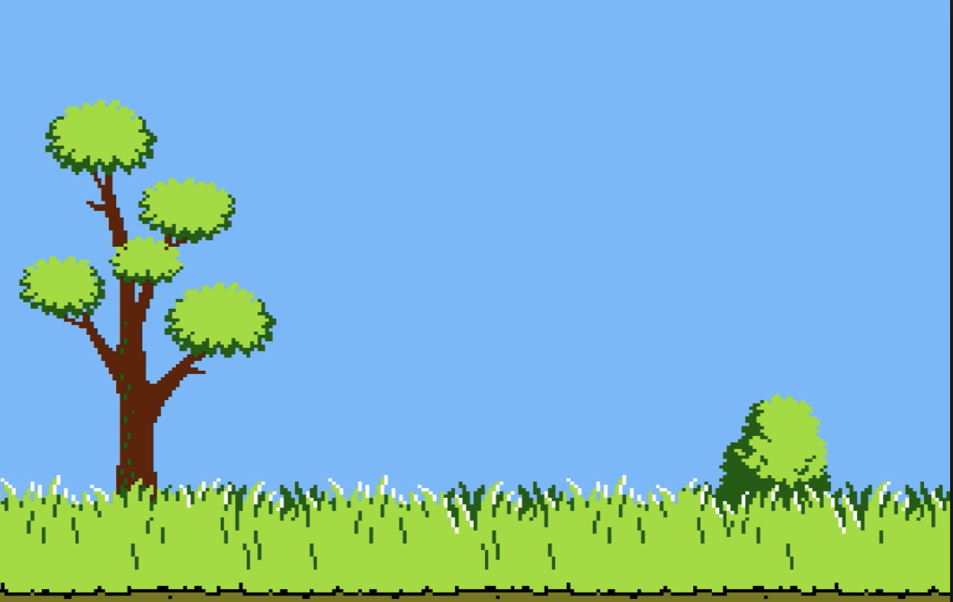

Background of Game Mode B



Background of Game Mode C

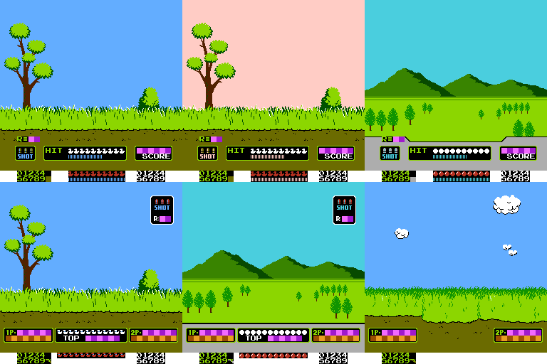

Animation loop for hound at the start of the game





Clay Disk



Animation loop of red birds

|  |  |  |
| --- | --- | --- |
|  |  |  |

Animation loop of black birds

|  |  |  |
| --- | --- | --- |
|  |  |  |

Animation loop of blue birds

|  |  |  |
| --- | --- | --- |
|  |  |  |

**Sounds**

Duck Hunt Title Screen Theme (0:00-0:37) - <https://www.youtube.com/watch?v=MoGiGbMIGPM>

Plays whenever player is at the title screen

Duck Hunt Game Start (0:00-0:05) - <https://www.youtube.com/watch?v=5sGbjd9gayA>

Plays before round starts in Game Mode A or B

Miss (0:06-0:08) Plays when play fails to shoot target

Duck Get (0:09-0:10) Plays when player successfully shoots a duck

Clear (0:11-0:14) Plays when a round is cleared

Perfect (0:15-0:17) Plays when player shoots all targets in that round

and after the “Clear” theme has played

Duck Hunt Clay Shooting - <https://www.youtube.com/watch?v=O6s8zQHa7NY>

Plays before round starts in Game Mode C

Duck Hunt Game Over (0:06- 0:13) - <https://www.youtube.com/watch?v=4eGWRRPmHNc>

Plays when player does not pass a round in all game modes

https://processing.org/examples/sequential.html